Coding :

*import* java.io.*;  
*import* java.text.DecimalFormat;  
*import* java.util.*;  
  
*public class* CarRental {  
 *public static void* main(String[] args) *throws* IOException {  
 Formatter formatter;  
 DecimalFormat priceformatter = *new* DecimalFormat("#0.00");  
 *try*{  
 String Name,ic, Carname;  
 *double* deposit , priceperday = 0, balance;  
 *int* day;  
  
 FileReader fr = *new* FileReader("CarRental.txt");  
 BufferedReader br = *new* BufferedReader(fr);  
  
 FileWriter fw1 = *new* FileWriter("PaymentBalance.txt");  
 PrintWriter pw1 = *new* PrintWriter(fw1);  
 FileWriter fw2 = *new* FileWriter("Customer.txt");  
 PrintWriter pw2 = *new* PrintWriter(fw2);  
  
  
 String line = br.readLine();  
 formatter = *new* Formatter();  
  
 pw1.println(formatter.format("%-40s %-20s %-20s %-20s %-10s %-10s %-15s %n", "CUSTOMER NAME"," IC NUMBER", "TYPE OF CAR", "NUMBER OF DAYS", "DEPOSIT", "TOTAL", "BALANCE"));  
 formatter = *new* Formatter();  
  
 pw2.println(formatter.format("%-40s %-20s %-20s %-20s", "CUSTOMER NAME", "IC NUMBER", "TYPE OF CAR", "BALANCE"));  
 *while* (line != *null*)  
 {  
 StringTokenizer st = *new* StringTokenizer(line, ";");  
 Name = st.nextToken();  
 ic = st.nextToken();  
 day = Integer.*parseInt*(st.nextToken());  
 Carname = st.nextToken();  
 deposit = Double.*parseDouble*(st.nextToken());  
  
 *if*(Carname.equalsIgnoreCase("Toyota Vellfire"))  
 {  
 priceperday = 750.0;  
 }*else if*(Carname.equalsIgnoreCase("Honda Civic"))  
 {  
 priceperday = 550.0;  
 }*else if*(Carname.equalsIgnoreCase("Proton Preve"))  
 {  
 priceperday = 300.0;  
 }*else if*(Carname.equalsIgnoreCase("Perodua Myvi"))  
 {  
 priceperday = 250.0;  
 }  
   
 *double* total_payment = day * priceperday;  
 balance = total_payment - deposit;  
  
 formatter = *new* Formatter();  
 pw1.println(formatter.format("%-40s %-20s %-20s %-20s %-10s %-10s %-15s", Name, ic, Carname, day, deposit, priceformatter.format(total_payment), priceformatter.format(balance)));  
  
 *if*(balance>1000){  
 formatter = *new* Formatter();  
 pw2.println(formatter.format("%-40s %-20s %-20s %-20s", Name, ic, Carname, priceformatter.format(balance)));  
 }  
 line = br.readLine();  
 }  
 pw1.close();  
 pw2.close();  
 br.close();  
  
 }  
 *catch*(FileNotFoundException fnf)  
 {  
 System.***out***.print(fnf.getMessage());  
 }*catch*(EOFException ex)  
 {  
 System.***out***.println(ex.getMessage());  
 }*catch*(IOException io)  
 {  
 System.***out***.print(io.getMessage());  
 }*catch*(Exception nf)  
 {  
 System.***out***.print(nf);  
 }  
 *finally* {  
 System.***out***.println("System ends here... Bye Bye");  
 }  
 }  
}

Output :

Paymentbalance.txt

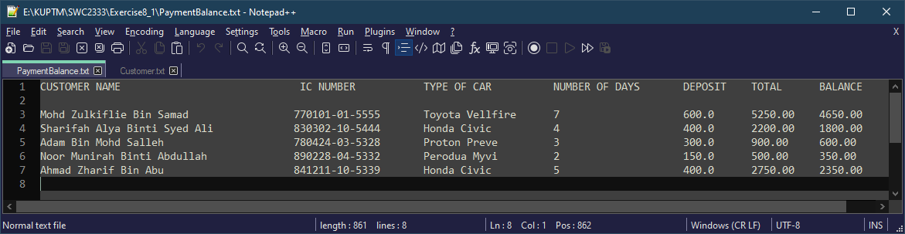

Customer.txt

